CURRICULUM VITAE
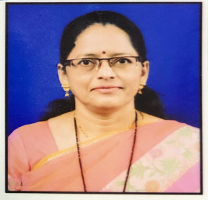
- Name : Dr. Pratibha C. Pavitrakar
- Designation : Assistant Professor & Head
Department of Music
Shri Shivaji Arts,Commerce and Science College
, Akot Dist. Akola
- Date of Birth : 22nd April 1973
- Address : “Swarangan” C/o Mr. P.P.Wagh
Nawle Wadi Akot Tq. Akot ,Dist. Akola Pin 444101(M/S)
Mob. No. 9765677434
Email : pratibhapavitrakar77@gmail .com
- Qualification : M.A. Ph.D
- Teaching Experience : U.G.Level : 20 Year
P.G.Level : 02 Year
- Research Experience : 12 years
Research Paper Published in International Journal : 04
- Published in Conferences/Seminars/Journals :
- National : 07
- International : 00
- State /Regional : 05
- Participations in Conferences/ Seminars :
- National : 07
- International : 02
- State /Regional : 03

- Paper Presented in Conference/ Seminars :
- National : 07
- International : 00
- State /Regional : 03
- UGC Minor Research Project : 01

- Ongoing : 00
- Completed : 01

- Professional Competence
- Orientation Course : 01
- Refresher Course : 03
- Short Term Course : 01
- Organization of Seminar
Coordinator of UGC Sponsored State Level Seminar on “Today”s Folk and Light Music Need Of Attention And Worries “ on 24 Feb 2014 At. Shri Shivaji Arts,Commerce and Science College , Akot Dist. Akola
- Member of Academic and Professional Bodies :
- Life Member of NUTA
- Life Member of Antar Bharti
- Guest Lecture : 04
- Awards and Honours : Ph.D Degree Awarded 12.11.2020

